PYTHON SOFTWARE INSTALLATION

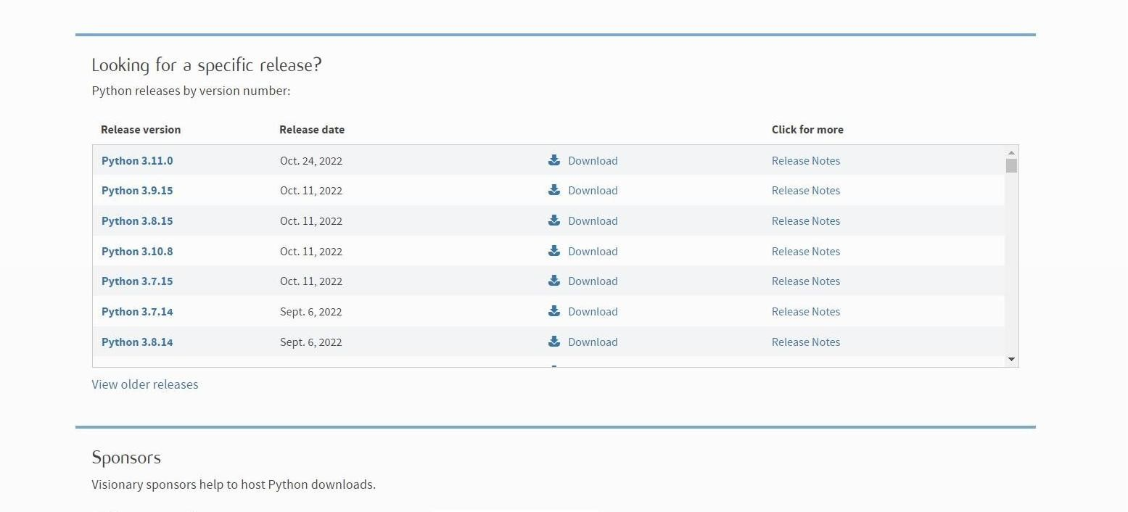

|  |  |
| --- | --- |
| Team ID | PNT2022TMID48924 |
| Project Name | Personal Assistance for Seniors Who Are Self-Reliant. |
| DATE | 19 November 2022 |

INSTALLATION PROCESS OF PYTHON:

**Step 1:** Type “**PYTHON”** in Google Search Bar and click first link.

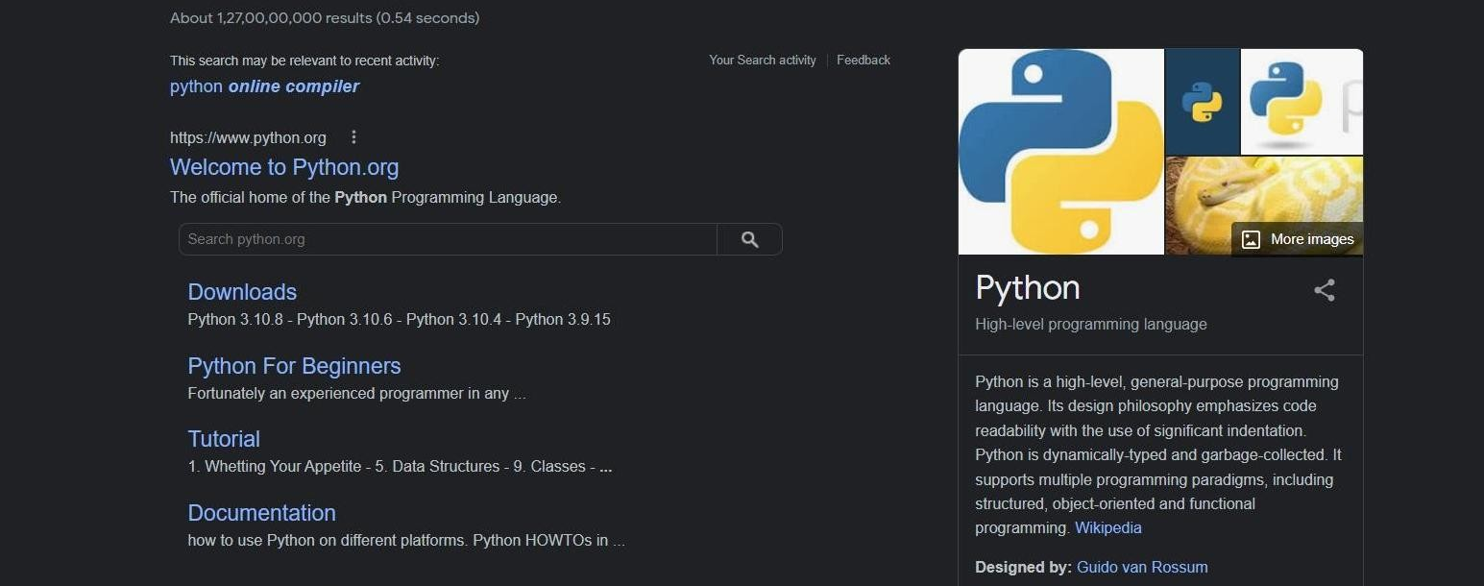

**Step 2:** Select Latest version of Python.

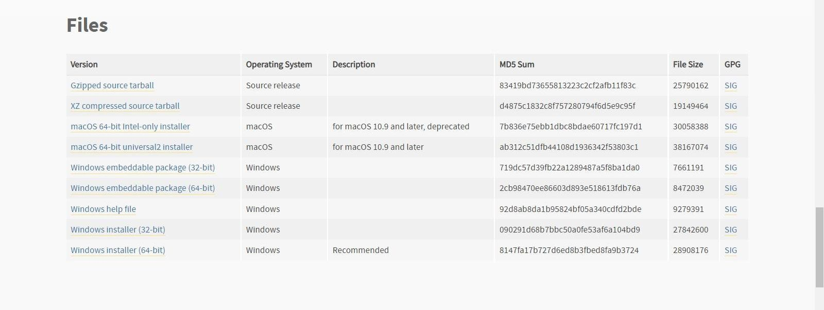

**Step 4:** Click on the Install Button

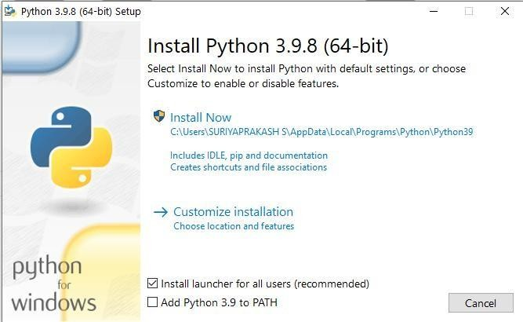

**Step 5:** Installation on progress.

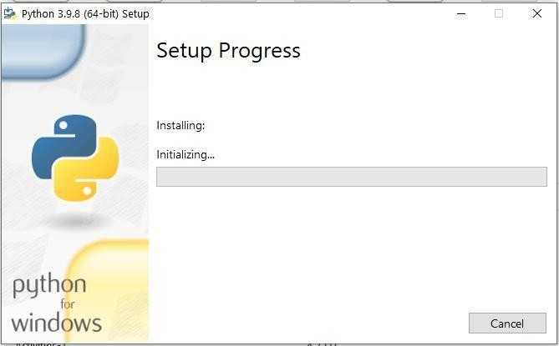

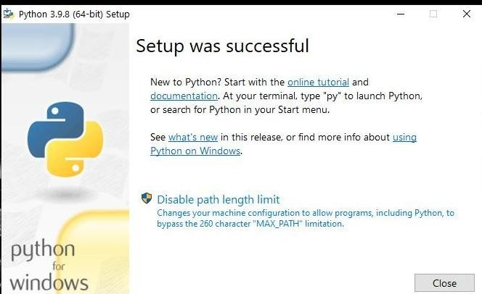

**Step 7:** Go to IDLE and open it.

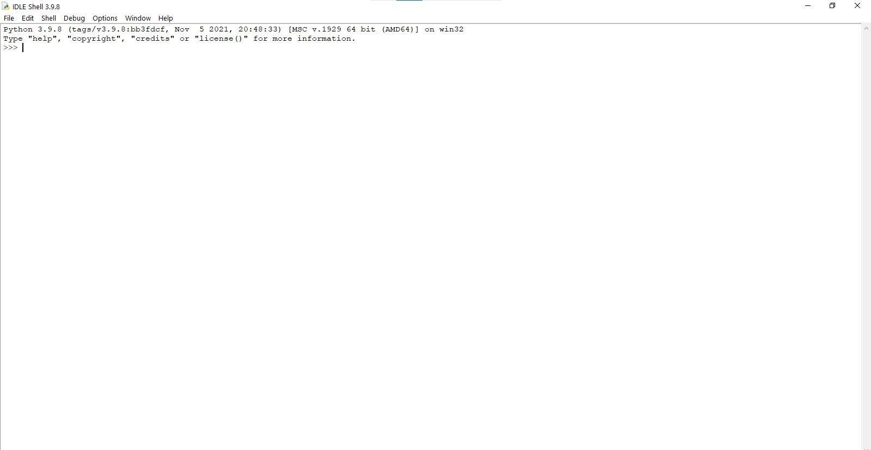

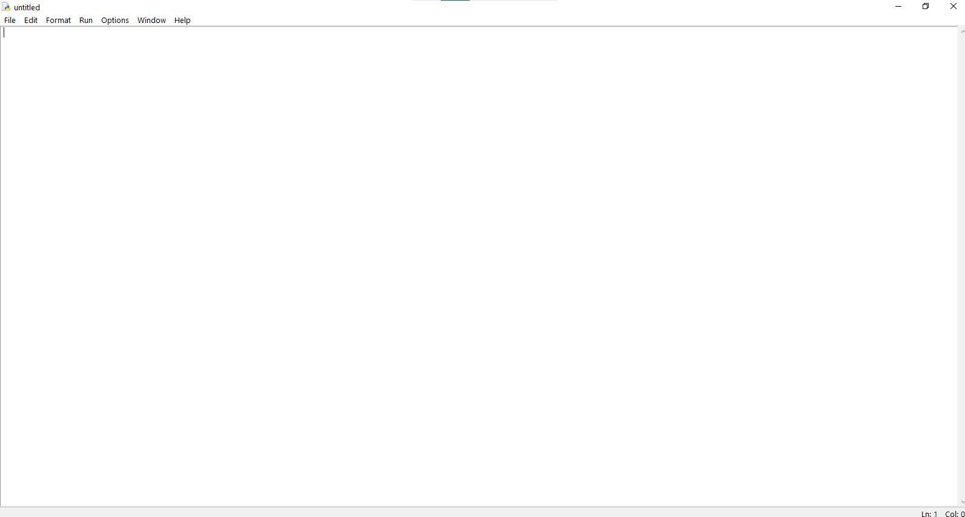

Finally, Python Installed Successfully.